**KALLAM HARANADHAREDDY INSTITUTE OF TECHNOLOGY**

**(AUTONOMOUS)**

**Project Title**

**Stationery Application to Manage the Inventory**

**By**

**Yandra Pragada Saivenkata Narasimha Nagesh (Team Leader)**

[**218x1a4b2@khitguntur.ac.in**](mailto:218x1a4b2@khitguntur.ac.in)

**Bodepudi Srilakshmi**

[**218x1a4268@khitguntur.ac.in**](mailto:218x1a4268@khitguntur.ac.in)

**Shaik Yasin**

[**218x1a4298@khitguntur.ac.in**](mailto:218x1a4268@khitguntur.ac.in)

**Shaik Sadiya**

[**218x1a4293@khitguntur.ac.in**](mailto:218x1a4268@khitguntur.ac.in)

**Project Abstract**

The Stationery Inventory Management Application helps businesses easily track and manage their stationery supplies. It allows users to monitor stock levels, categorize items, and keep track of usage to avoid running out of supplies or overstocking. The app simplifies ordering by keeping supplier details and automatically generating purchase orders when stocks are low. With an easy-to-use interface, it reduces the time spent on manual inventory tasks, prevents mistakes, and ensures that supplies are always available when needed. Overall, the application improves efficiency, saves time, and helps businesses control their stationery costs.

**INDEX**

|  |  |
| --- | --- |
| **S.No** | **Topics** |
| 1 | Introduction |
| 2 | Objective |
| 3 | Implementation Details |
| 4 | Outcomes |
| 5 | Challenges & Solution |
| 6 | Future Recommendation |
| 7 | Conclusion |

**INTRODUCTION**

### The Stationery Inventory Management Application is a simple solution for businesses to keep track of their office supplies. It helps users easily monitor the quantity of items like pens, paper, and other stationery products. The app makes it easy to see when supplies are running low and automatically alerts users to reorder before running out. By organizing and managing inventory efficiently, this application saves time, reduces errors, and helps businesses avoid overstocking or shortages. With an easy-to-use design, the app ensures businesses can manage their stationery needs in a smooth and cost-effective way.

### **Objectives**

1. **Manage Stationery Items:**

* Organize and track different stationery items like pens, paper, folders, and other office supplies.
* Categorize items for easy search and better organization.

1. **Track Orders:**

* Monitor and manage orders for stationery supplies.
* Automatically generate purchase orders when stock levels are low.

1. **Billing and Invoicing:**

* Create and manage invoices for stationery purchases.
* Keep records of payments and outstanding bills.

1. **Employee Management:**

* Track stationery usage by employees.
* Assign and monitor stationery items issued to employees.

1. **Vendor Management:**

* Maintain a list of vendors supplying stationery items.
* Track purchase history and manage relationships with vendors.

1. **Stock Management:**

* Monitor and update stock levels regularly.
* Ensure timely restocking by keeping track of inventory and vendor deliveries.

### **Methodology**

1. **Data Collection:**

* First, gather information about all stationery items, including their names, categories, and quantities.
* Add details of vendors supplying the items, including contact information and prices.

1. **Inventory Tracking:**

* Track the quantity of each stationery item in real-time.
* Regularly update stock levels as items are used or new stock is received.

1. **Define System Requirements:**

* Identify the key features needed for the inventory management system.
* Determine the roles and permissions required for different users.

1. **Configure Security and Access:**

* Set up profiles and roles to control user access to data.
* Configure organization-wide defaults for record visibility.

1. **Develop Automation Processes:**

* Create validation rules to ensure data accuracy.
* Set up approval processes for tasks like purchasing orders.

1. **Create Reporting Tools:**

* Develop reports to track inventory levels and sales trends.
* Design dashboards to visualize key metrics.

### **Implementation Details:**

1. **Salesforce developer account creation:**

* Creating a developer org in salesforce.
* Go to <https://developer.salesforce.com/signup>

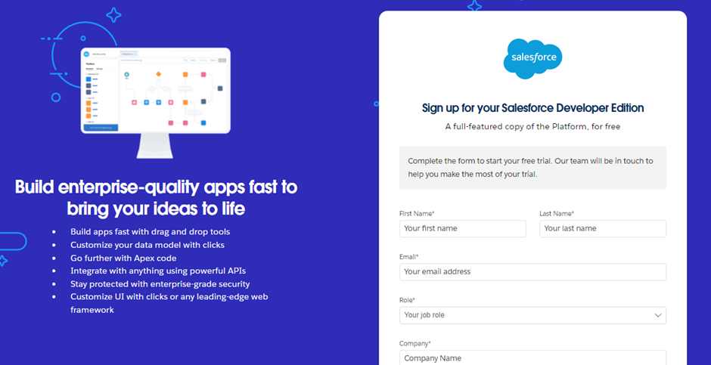

**Account Activation:**

* Click on Verify Account
* Give a password and answer a security question and click on change password.
* Then you will redirect to your salesforce setup page.

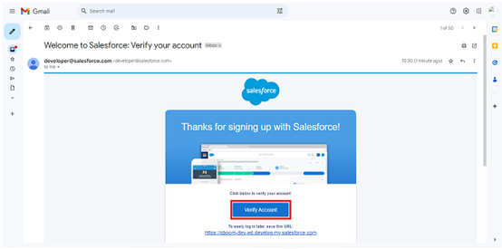

1. **Object Creation:**

* We accessed the Setup page by logging into our Salesforce account and selecting Setup from the gear icon.And navigated to the Object Manager tab beside the Home tab.
* On the Object Manager page, we clicked Create and selected Custom Object.we set the Label to "Stationery Item", Plural Label to "Stationery Items", Record Name to "Stationery Items Name", and Data Type to Text, and enabled Allow Reports and Allow Search. Finally Saved.

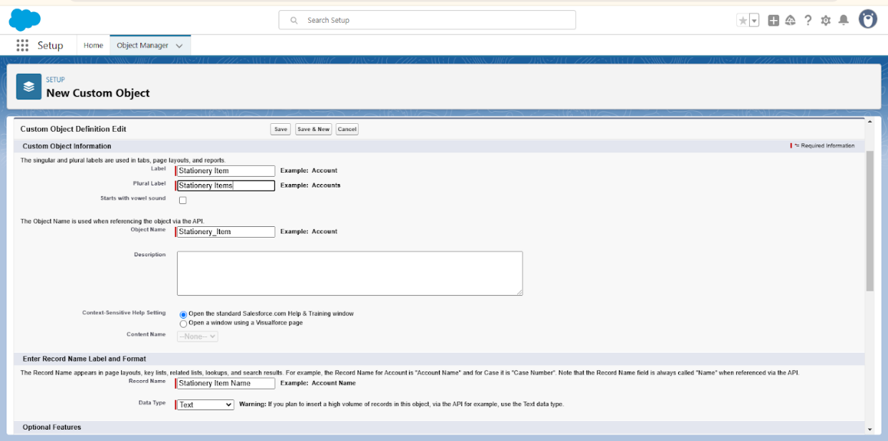

* Similarly We created Objects for Orders, Billing, vendors, Employes, Stock from Vendors, Vendor Bill.

1. **Creating Tabs for Custom Objects:**

* Entered "Tabs" in the Quick Find box and select Tabs. Under Custom Object Tabs, click New. Choose the object (e.g., Stationery Item), select a tab icon, and leave other settings as is. Click Next, Next, and Save.
* Repeat for Orders, Billings, Employees, Vendors, Stock from Vendors, and Vendor Bills. 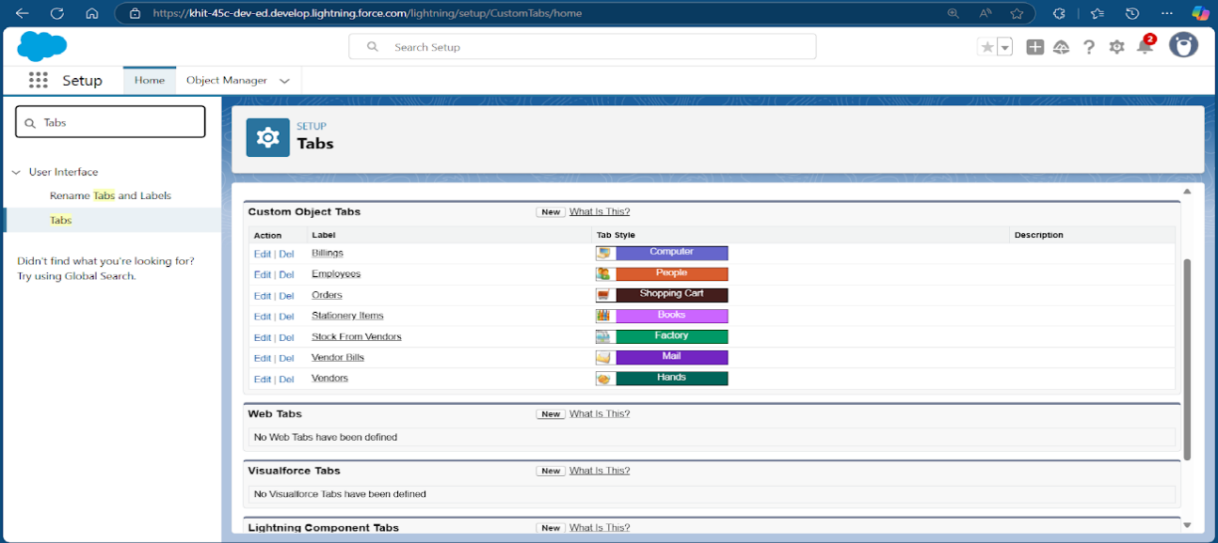

1. **Creating the Stationery App:**

* We created the Stationery app by entering "App Manager" in the Quick Find, clicking New Lightning App, naming it "Stationery", leaving default settings, adding necessary navigation items, assigning the System Administrator profile, and clicking Save & Finish.

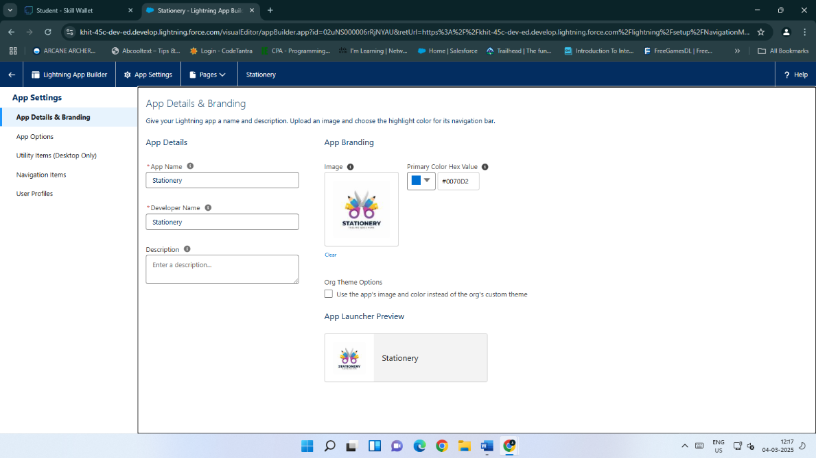

1. **Creating Fields and Relationship:**

* We created fields by navigating to the object, clicking on Fields & Relationships, selecting New Field, choosing the data type, entering a label and name, configuring additional settings as needed, and clicking Save.

|  |  |
| --- | --- |
| **Object Name** | **Field Names** |
| Stationery Item | Stationery Items Name, Item No, Quantity, Vendor Name, Stationery Type, Unit Price, Cost Price per Unit, Profit per Unit |
| Order | Customer Name, Order No, Stationery Item, Quantity, Order Status, Amount, Email |
| Billing | Billing No, Customer Name, Order No, Email, Total Amount |
| Vendor | Vendor ID, Vendor Name, Vendor Phone No, Email, Address |
| Stock From Vendor | Vendor Name, Vendor ID, Stock Order No, Stock Item Name, Stationery Type, Quantity, Cost Price per Unit, Selling Price per Unit, Total Cost, Approval Status, Bill Status, Stock Updated in Stationery |
| Vendor Bill | Vendor Name, Vendor Bill No, Stock Order No, Vendor Bill Amount, Email |
| Employee | Employee No, Employee Name, Employee Role, Phone No, Salary, DOB |

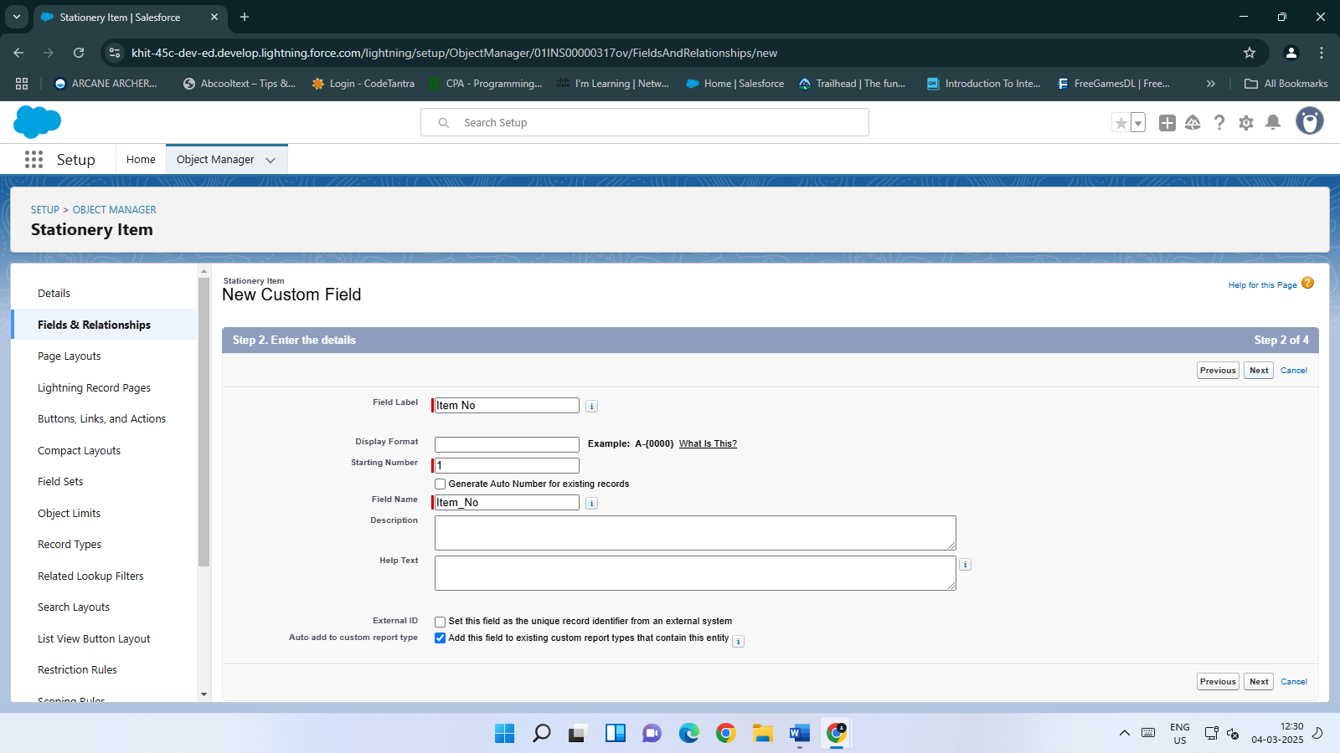

1. **Creation of Page Layouts:**

* We edited the Stationery Item object by going to the Setup page, clicking on Object Manager, and selecting Edit for the Stationery Item object. Then, we clicked on Page Layouts, selected the Stationery Item Layout, dragged and arranged the fields as needed, and clicked Save to finalize the layout changes.

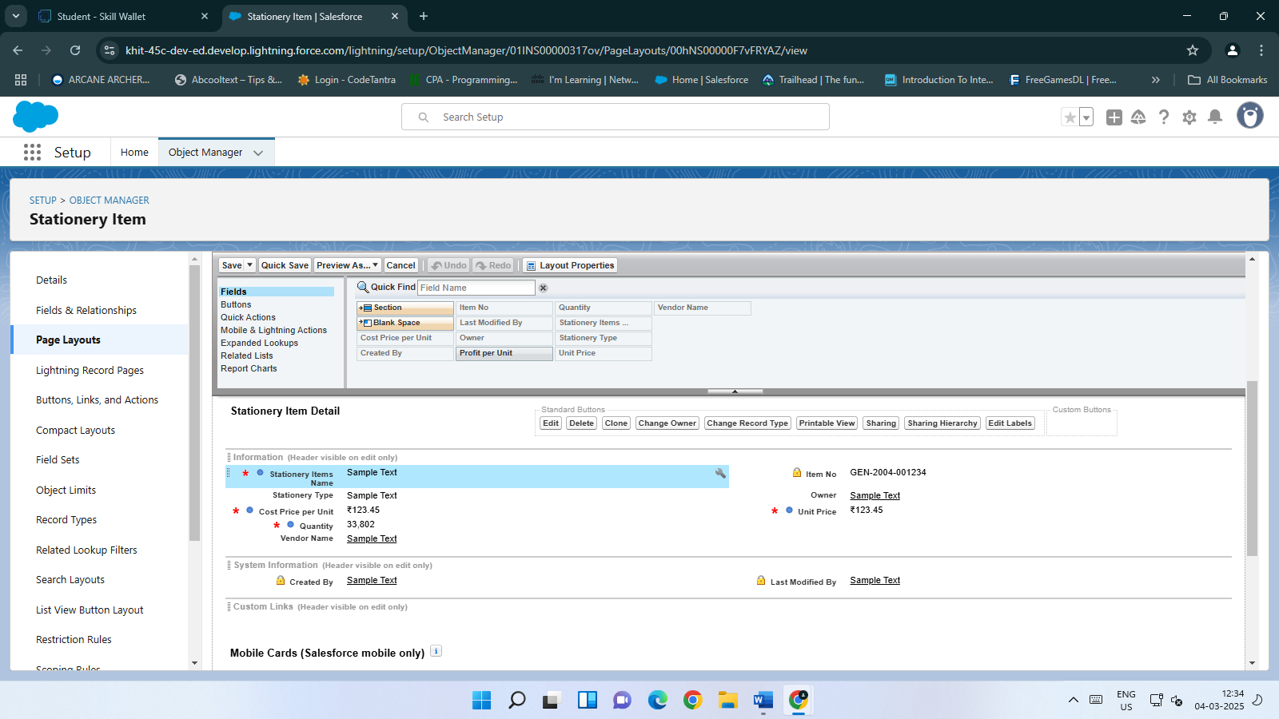

1. **Creation of Validation rule:**

* We created multiple validation rules for various objects by editing them in Object Manager, defining conditions to enforce specific constraints, and setting error messages to notify users when these conditions are not met.

| **Validation Rule Name** | **Formula Used** | **Description** |
| --- | --- | --- |
| Quantity_check_Rule | Quantity__c > Stationery_Item__r.Quantity__c | Ensures the ordered quantity does not exceed the available quantity in Stationery Items. |
| Order_No_checking | AND(Order_No__c <> Customer_Name__r.Order_No__c, Customer_Name__c <> Customer_Name__r.Name) | Verifies that the Order No and Customer Name in Billing match those in the Order list. |
| Vendor_ID_Checking | AND(Vendor_ID__c <> Vendor_ID__r.Name, Name <> Vendor_ID__r.Vendor_Name__c) | Checks that the Vendor ID and Vendor Name in Stock From Vendor match those in the Vendors list. |
| Vendor_Order_No_Checking | AND(Stock_Order_No__c <> Vendor_Name__r.Stock_Order_No__c, Vendor_Name__c <> Vendor_Name__r.Name) | Ensures the Order No and Vendor Name in Vendor Bill match those in Stock From Vendors. |

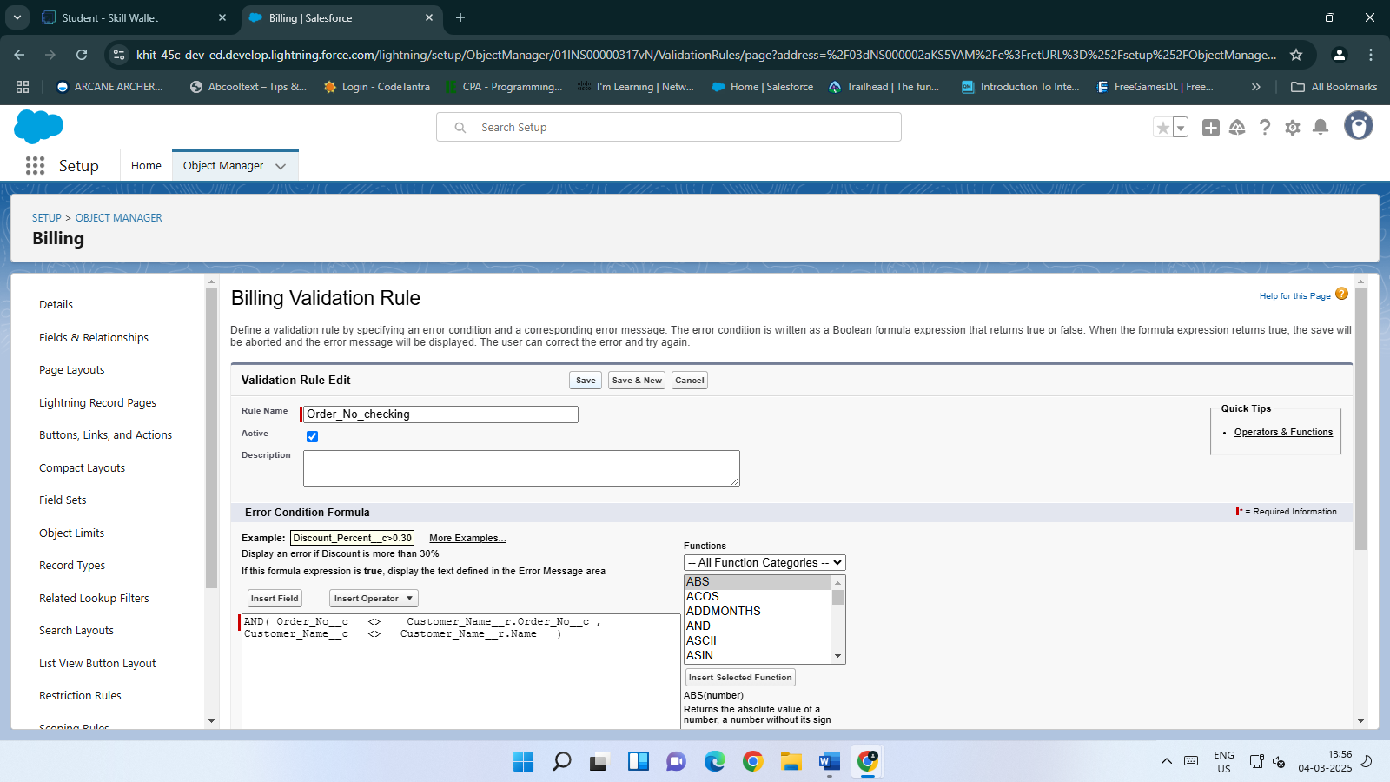

1. **Creation of Profiles:**

* We created two profiles: Stationery Admin Profile and Stationery 1 Platform User.

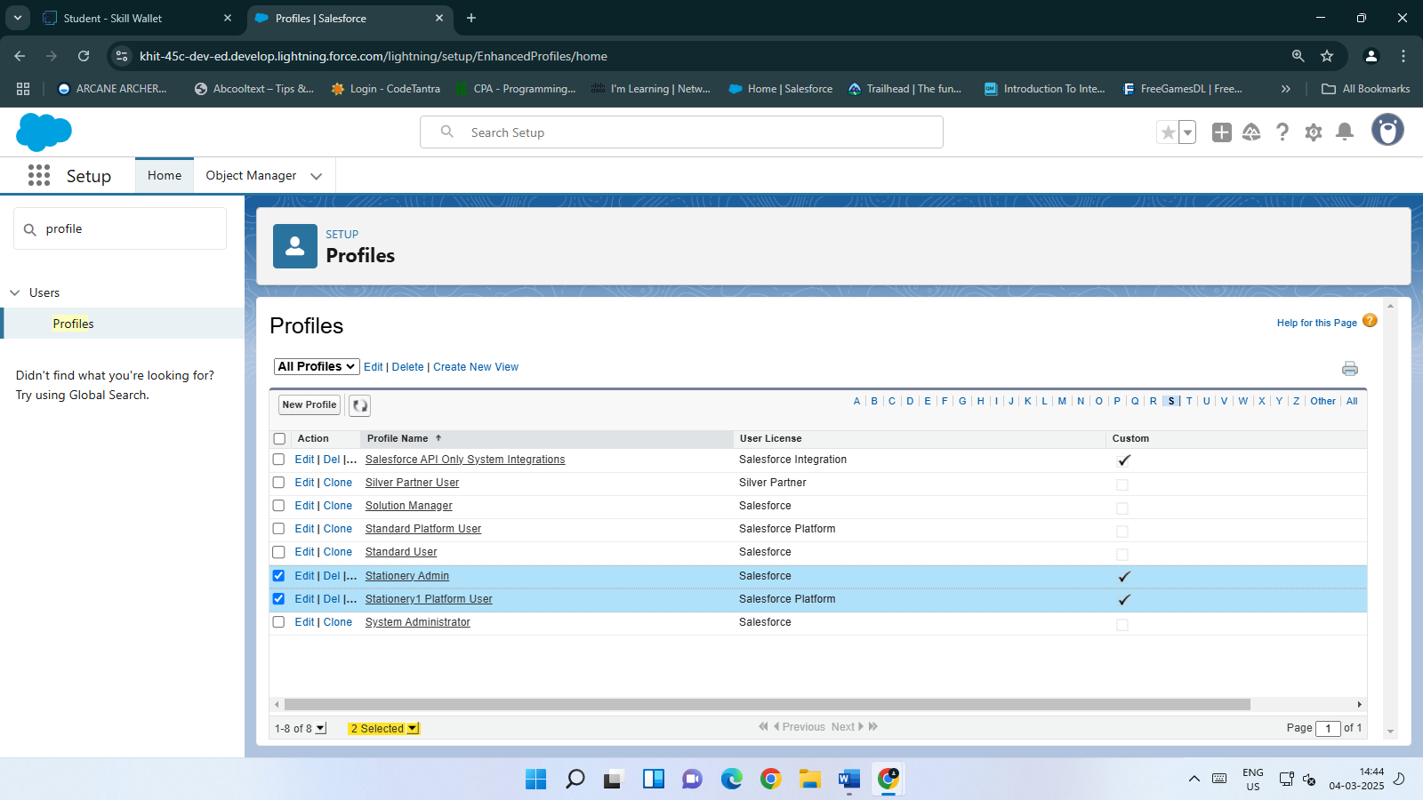

1. **Creation of Role & Role Hierarchy:**

* We created roles by navigating to the Roles setup page. First, we created the Owner role by adding it under the top-level role. Then, we created another role named Vendor under the CEO role.

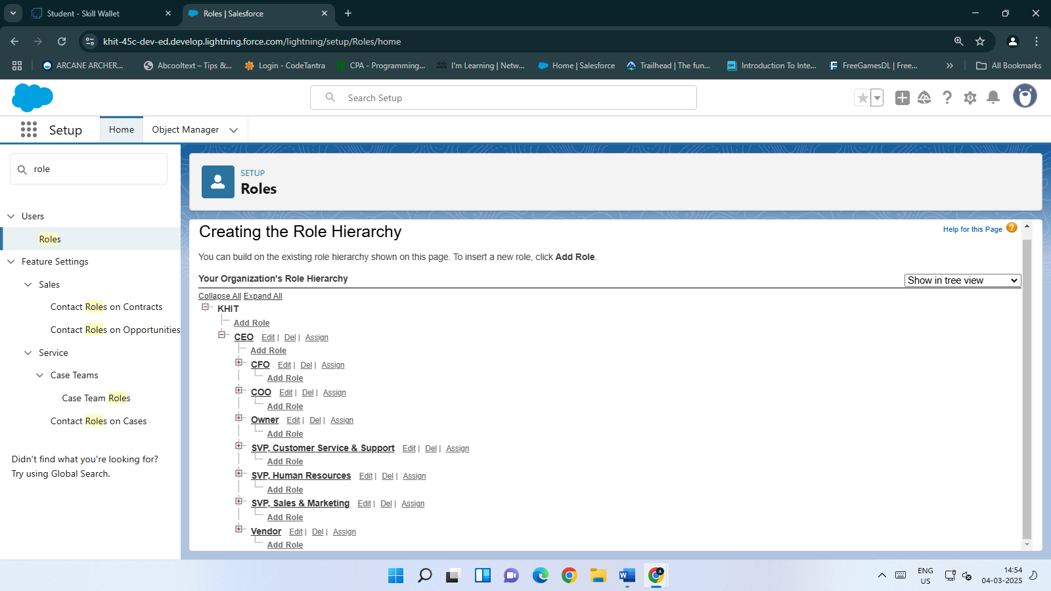

1. **Creation of Users:**

* We created three users: Sri Manikanta (Stationery Admin profile), Agarwal Deshmukh, and Bhavani Aroor (Stationery 1 Platform User profile). For each user, we entered their details, assigned roles, selected the appropriate profile, and ensured they received login credentials via email.

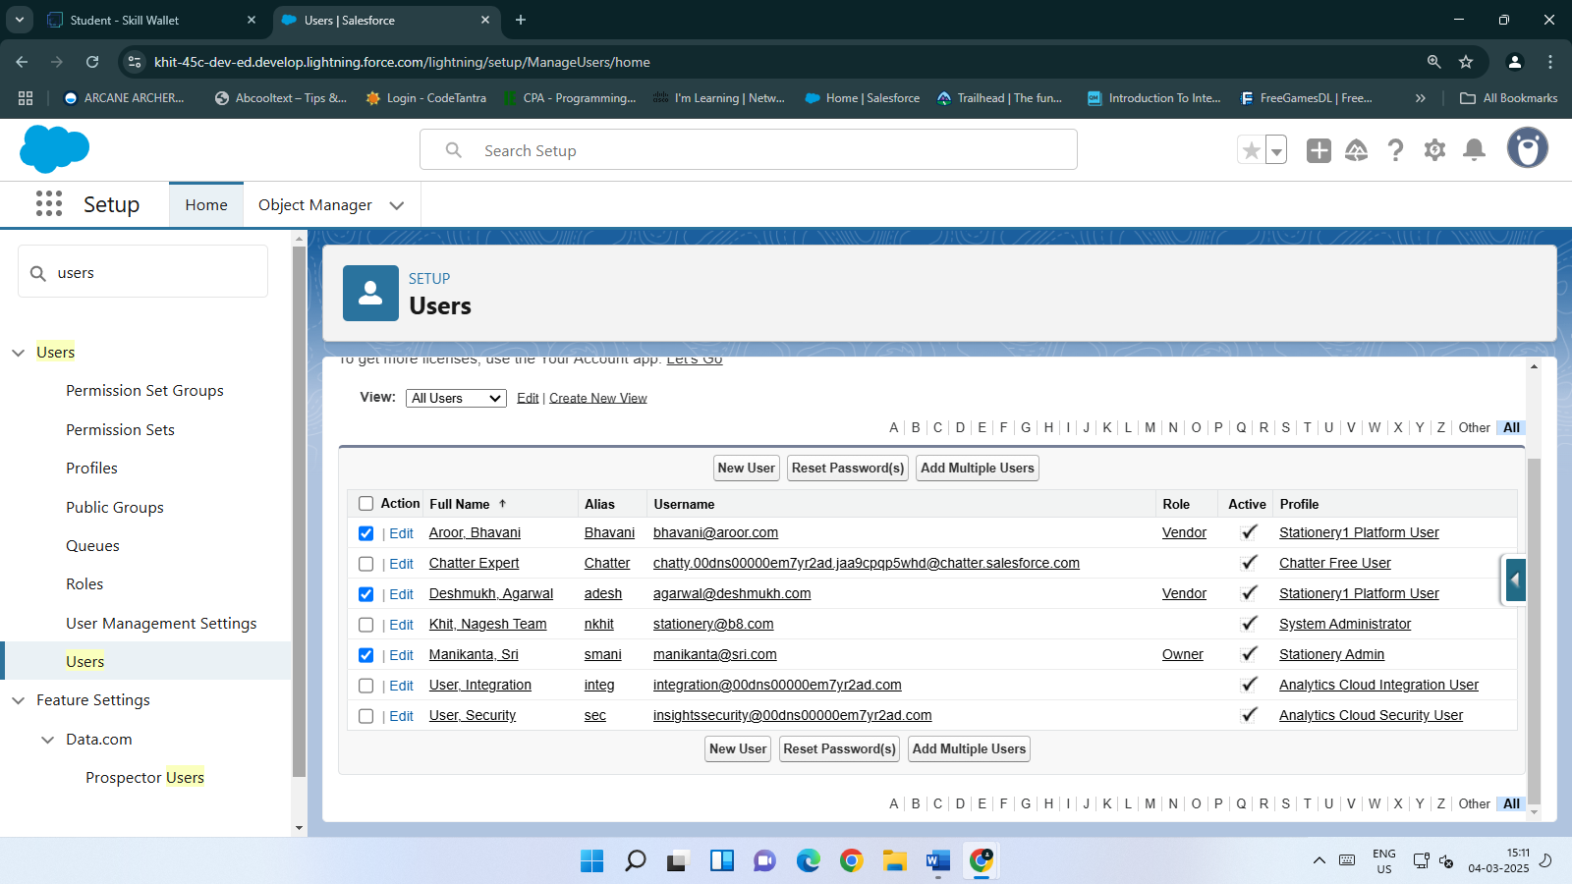

1. **Creation of Setup For OWD:**

* We configured Organization-Wide Defaults (OWD) by setting Employee and Stationery objects to Public Read/Write and Vendor to Private. This ensures each profile has its own access. We also created a Vendor Sharing Rule, labeling it "Access to Owner," based on the record owner, and set it to share with selected roles and owners at a Read/Write access level.

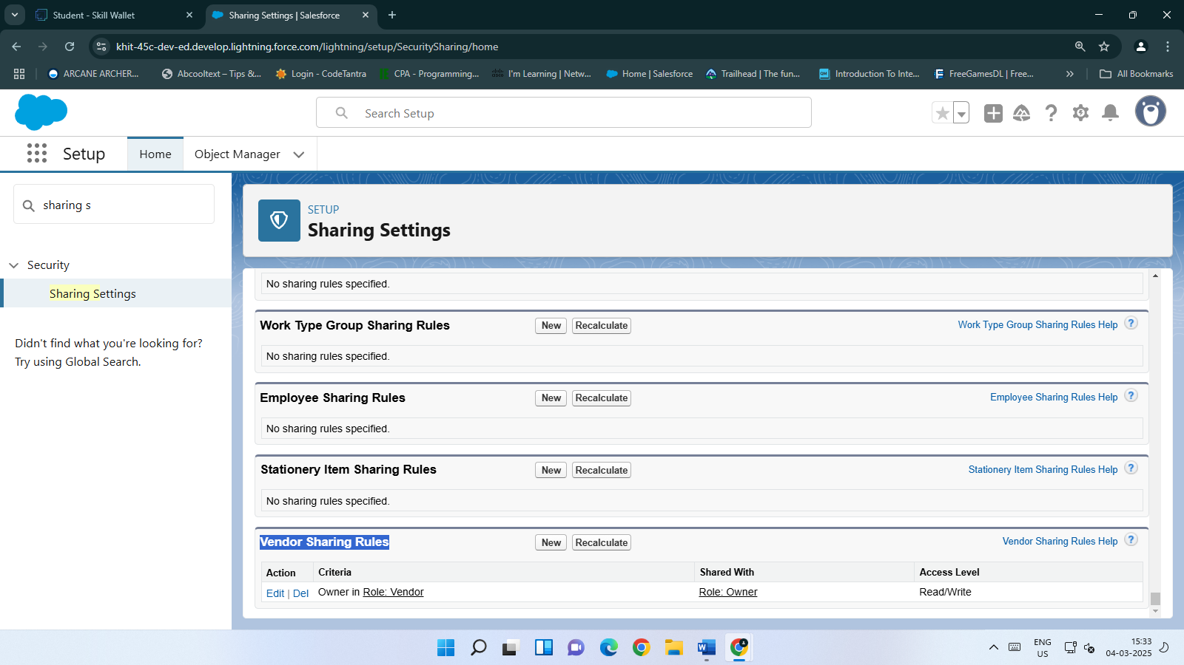

1. **Creation of Email Templates:**

* **Upload Logo:** Navigated to Salesforce Branding in Setup, edited the loading page logo, uploaded the image, and saved it.
* **Create Letterhead:** Created a new letterhead labeled STATIONERY, marked it as available for use, selected the uploaded logo, and saved it.
* **Create Email Template:** Created an HTML email template using the Classic Letterhead with the following details:
* **Template Name:** Approval Status Confirmation
* **Subject:** Please Approve the details about new stock
* **Body:**

*Hello,*

*Item Name: {!Stock_From_Vendors__c.Stock_Item_Name__c}*

*Cost Price per Unit: {!Stock_From_Vendors__c.Cost_Price_per_Unit__c}*

*Selling Price: {!Stock_From_Vendors__c.Selling_Price_per_Unit__c}*

*Quantity: {!Stock_From_Vendors__c.Quantity__c}*

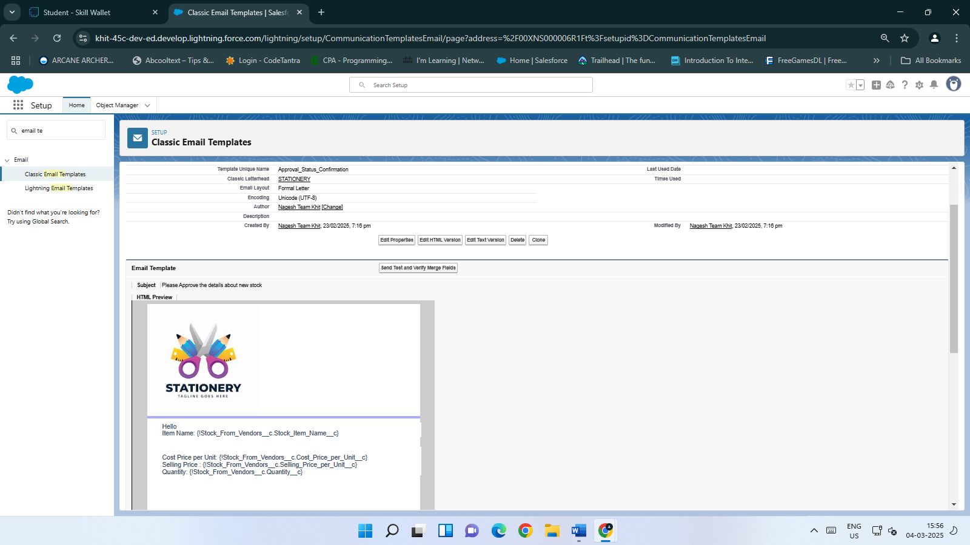

1. **Creation of Approval Process:**

* We created a Stock Approval process in Salesforce using the Jump Start Wizard. The process allows administrators or approvers to edit records during approval, uses the "Approval Status Confirmation" email template, and displays key fields like Vendor Name and Quantity. Agarwal Deshmukh and others are allowed to submit for approval, with Sri Manikanta assigned as the approver. The process updates the status to Pending upon submission, Approved or Rejected upon final decision, and unlocks the record accordingly.

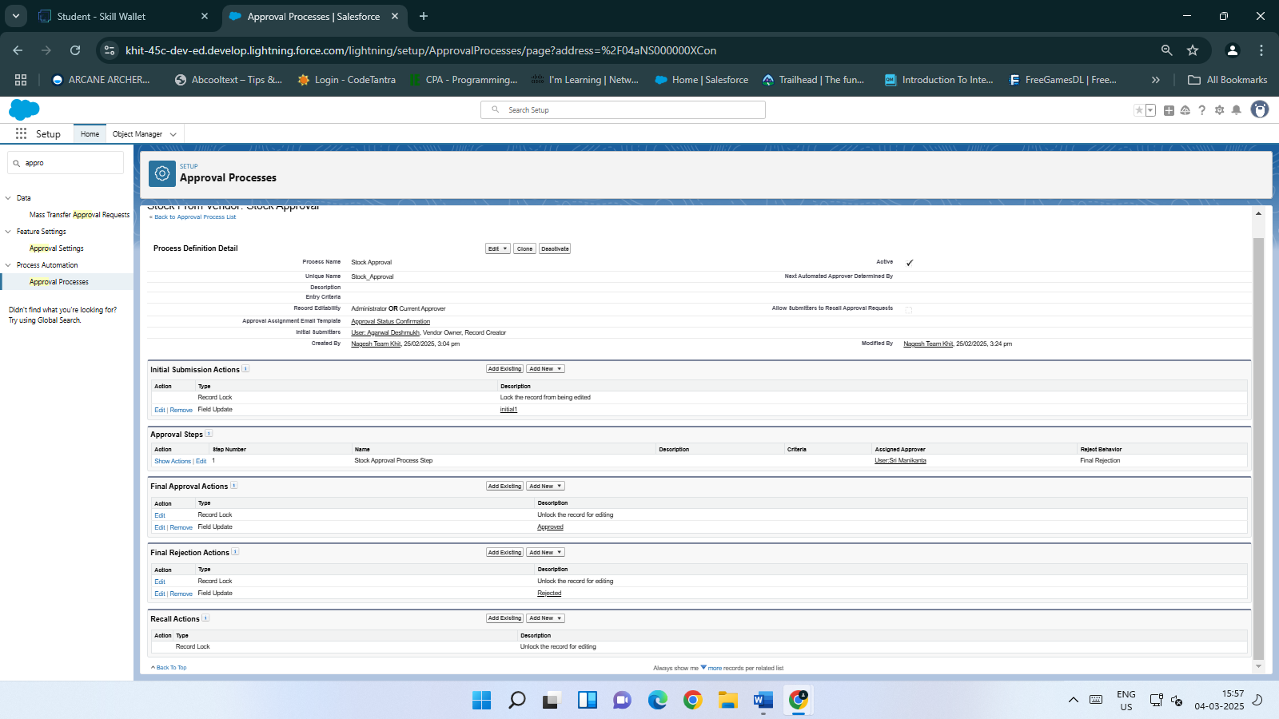

1. **Creation of Flows:**

* We created several flows in Salesforce to automate business processes:
* **Total Bill Amount Generating Flow:** Calculates and updates the total bill amount in Billing records and changes the Order status to "Delivered."
* **Vendor Bill Generation Flow:** Calculates and updates the vendor bill amount based on approved Stock From Vendor records.
* **Stationery Quantity Updation Flows:** Updates Stationery Item quantities when Orders are created, updated, or deleted.
* **New Stock Updation In Stationery Items Flow:** Updates Stationery Item quantities when new stock is approved and updated in Stock From Vendor records.
* These flows streamline billing, vendor billing, and inventory management processes.

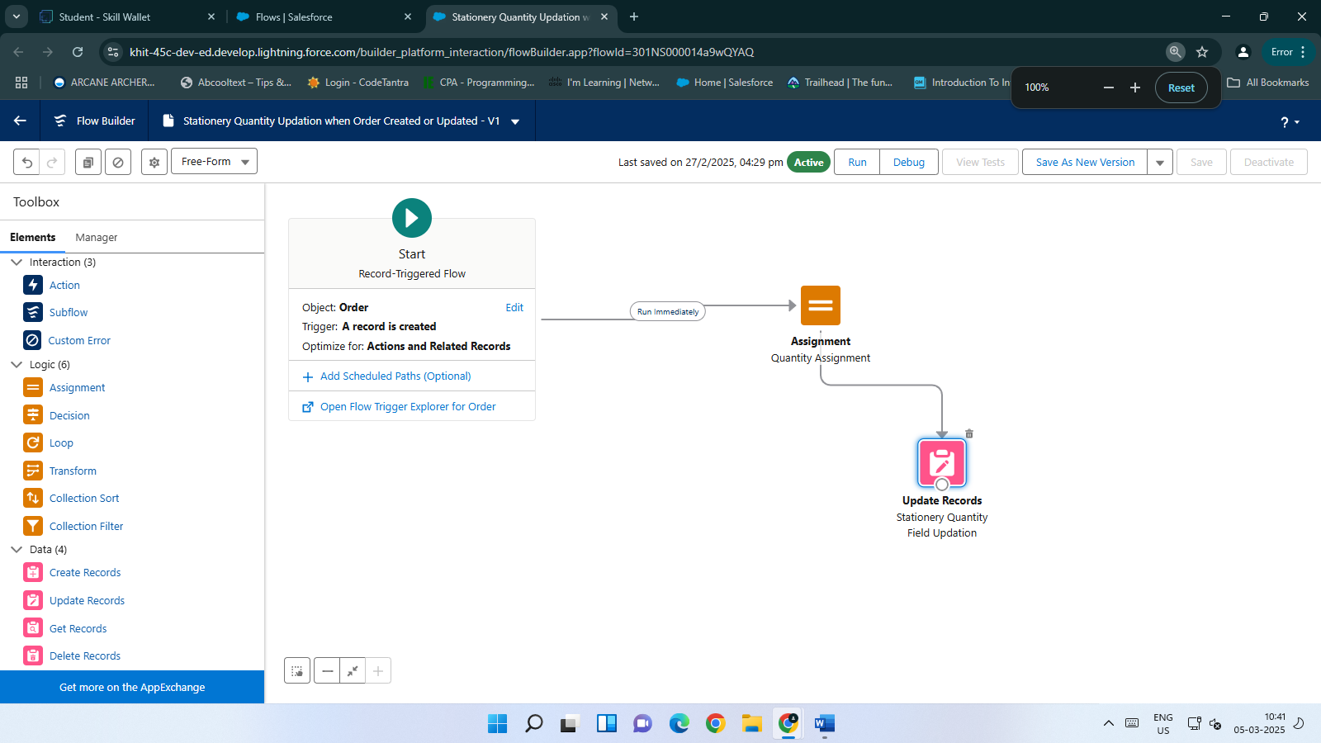

1. **Creation of Reports:**

* We created a "Weekly Stationery Profit Report" in Salesforce by selecting the "Stationery Items with Orders" report type, adding summary fields, and grouping rows by Stationery Item. The report is accessible via the Stationery App's Reports tab.

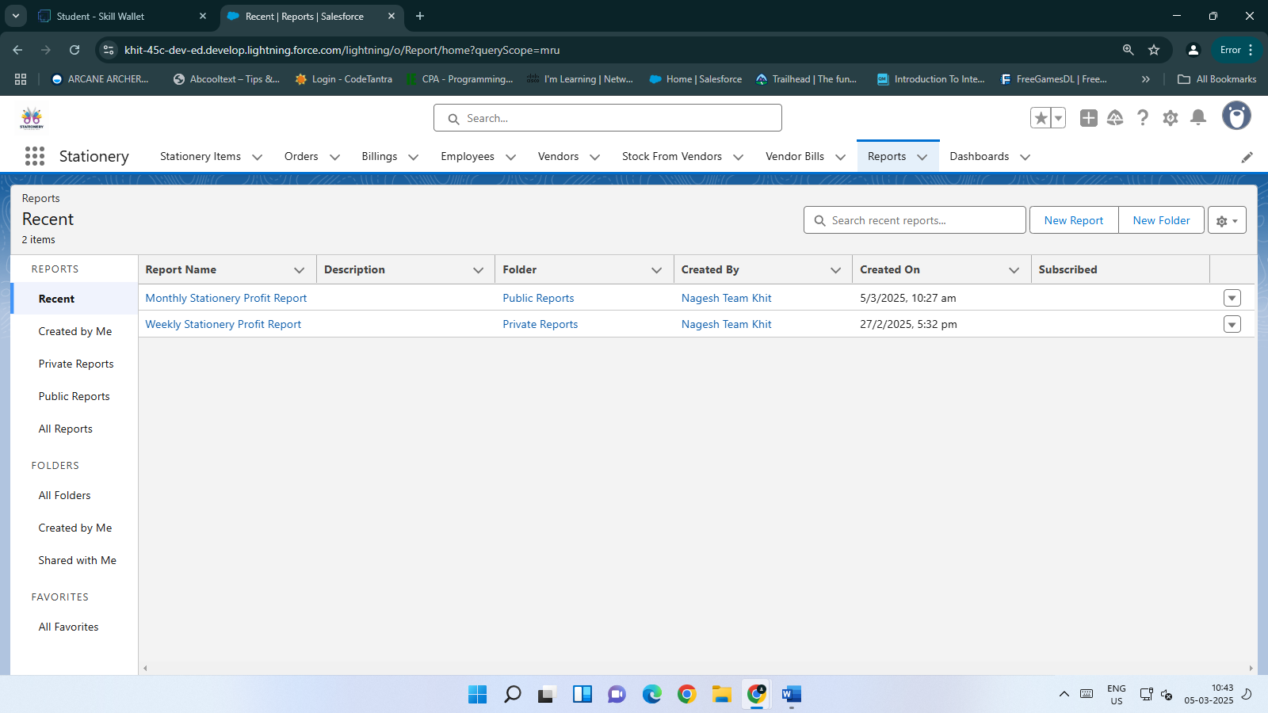

1. **Creation of Dashboards:**

* We created a dashboard named "Orders Information Weekly Basis" in the Stationery App. This dashboard features a widget based on the "Weekly Stationery Profit Report," which we customized with a chosen data visualization such as a chart or table. After adding the widget, we saved the dashboard. To view it, we navigate to the Stationery App, click on the Dashboards tab, and select "Orders Information Weekly Basis" to see a graphical view of the records. This dashboard provides a visual representation of stationery profit data, making it easier to analyze trends and insights.

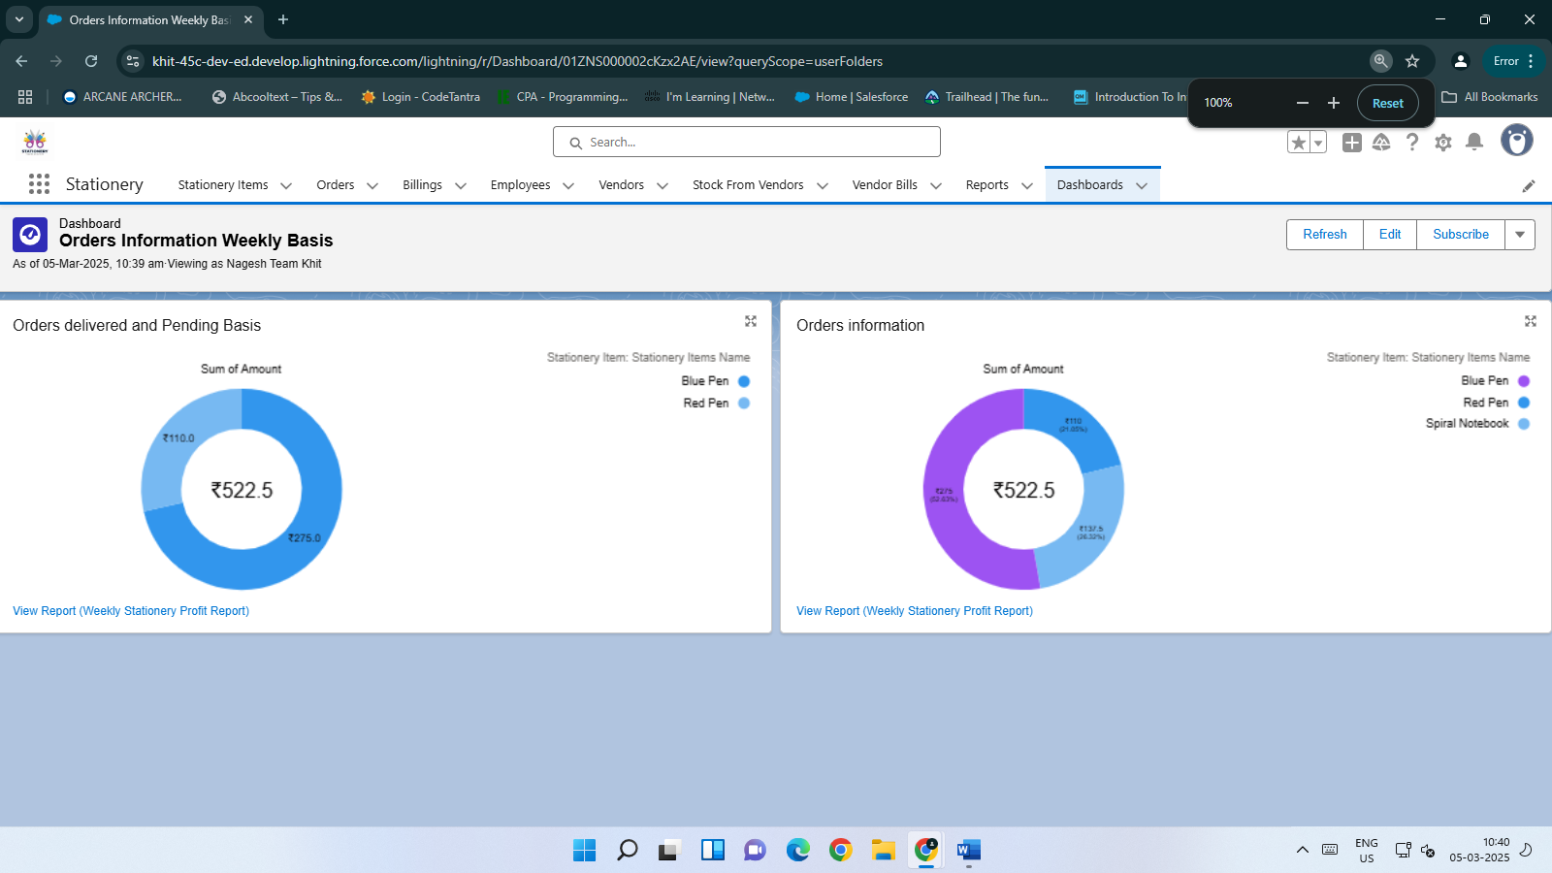

**Automations**:

1. **Automatic Reordering:**

* **Functionality:** When the stock level of a stationery item falls below a predefined threshold, the system automatically generates a purchase order to restock the item.
* **Benefits:** Ensures timely replenishment of stock, preventing stockouts and maintaining operational efficiency.

1. **Stock Level Alerts:**

* **Functionality:** The system sends automatic notifications to relevant personnel when inventory levels are low or when it’s time to reorder items.
* **Benefits:** Keeps stakeholders informed about stock levels, allowing for proactive management and reducing the risk of stockouts.

1. **Usage Tracking:**

* **Functionality:** Automatically tracks the usage of stationery by employees and updates stock levels in real-time.
* **Benefits:** Provides accurate and up-to-date information on stock usage, enabling better inventory management and reducing waste.

1. **Invoice Generation:**

* **Functionality:** Automatically generates invoices when an order is placed and sends them to the accounting team for processing.
* **Benefits:** Streamlines the billing process, reduces manual errors, and ensures timely payment processing.

1. **Vendor Communication:**

* **Functionality:** Sends automatic reminders to vendors about pending orders or upcoming deliveries.
* **Benefits:** Enhances vendor communication, ensures timely delivery of goods, and helps maintain strong vendor relationships.

1. **Report Generation:**

* **Functionality:** Automatically generates and updates reports on stock levels, order history, and vendor performance at scheduled intervals.
* **Benefits:** Provides regular insights into inventory management and vendor performance, enabling data-driven decisions and continuous improvement.

### **Outcomes:**

### **Better Stock Control:**

### **Description:** The system ensures accurate tracking of stock levels, enabling timely reordering and preventing stockouts or overstocking.

### **Benefits:**Real-time Inventory Tracking: Always know what’s in stock and when to reorder.

### **Optimized Stock Levels:** Prevent shortages or overstocking by maintaining optimal inventory levels.

### **Reduced Stockouts:** Minimize disruptions caused by stockouts, ensuring continuous operations.

### **Reduced Overstocking:** Avoid unnecessary storage costs and reduce waste by not overstocking.

### **Time Savings:**

### **Description:** Automates tasks such as ordering, invoicing, and stock tracking, significantly reducing manual effort and saving time.

### **Benefits:**Automated Processes: Automate tasks like ordering, invoicing, and stock tracking.

### **Increased Productivity:** Employees can focus on more strategic tasks rather than manual data entry.

### **Faster Response Times:** Quickly respond to stock needs and customer requests.

### **Reduced Errors:** Minimize errors associated with manual data entry.

### **Cost Savings:**

### **Description:** Helps avoid unnecessary purchases and wastage by accurately tracking usage and stock levels.

### **Benefits:** Accurate Stock Tracking: Avoid overbuying by knowing exactly what’s in stock.

### **Reduced Wastage:** Minimize expired or unused stock by tracking usage and stock levels.

### **Optimized Purchases:** Make informed purchasing decisions based on actual needs.

### **Lower Storage Costs:** Reduce storage costs by maintaining optimal inventory levels.

### **Improved Efficiency:**

### **Description**: Streamlines the entire inventory process, from ordering to tracking, making it easier for employees to manage supplies.

### **Benefits:** Streamlined Processes: Simplify the inventory management process with automated workflows.

### **Enhanced Employee Experience:** Employees can easily manage supplies and track stock without extensive manual effort.

### **Better Decision Making:** Provide insights for data-driven decisions on inventory management.

### **Increased Transparency**: Offer real-time visibility into inventory levels and transactions.

### **Additional Outcomes:**

### **Enhanced Customer Satisfaction:** Timely delivery of orders due to efficient stock management.

### **Improved Vendor Relationships:** Regular and accurate communication with vendors about orders and stock levels.

### **Data-Driven Insights:** Regular reports and analytics provide insights into stock usage and trends, helping in strategic planning.

### **Challenges and Solutions:**

**Challenge: Stock Mismanagement**

* **Solution:** Set automatic reorder points and stock level alerts to ensure that stock is never too low or too high.

**Challenge: Manual Tracking Errors**

* **Solution:** Automate stock updates and usage tracking to reduce human errors and ensure real-time accuracy.

**Challenge: Delayed Orders**

* **Solution:** Implement vendor performance tracking and set automatic reminders to ensure timely order deliveries.

**Challenge: Overordering or Wastage**

* **Solution:** Use usage tracking and predictive reports to better estimate future needs and avoid overstocking.

### 

### **Future Predictions:**

### **Sustainability and Eco-Friendly Materials:**

### **Prediction**: The demand for sustainable and eco-friendly stationery will grow significantly. Products made from recycled materials, biodegradable packaging, and sustainable production practices will dominate the market.

### **Impact on Project:**

### Incorporate eco-friendly products into your inventory.

### Partner with vendors offering ethically sourced materials.

### Highlight sustainability credentials in marketing efforts.

### **Digital Integration and Smart Solutions:**

### **Prediction**: Hybrid stationery solutions, such as smart notebooks and digital pens, will bridge the gap between traditional and digital workflows. These products will sync handwritten notes with cloud storage or apps.

### **Impact on Project:**

### Expand inventory to include smart stationery products.

### Integrate digital tools into your system for seamless tracking of hybrid products.

### Offer training to employees on managing digital-integrated stationery.

### **Personalization and Customization:**

### **Prediction**: Personalized stationery items, such as custom notebooks, planners, and pens, will see increased demand. Customers will seek unique designs reflecting their individuality or brand identity.

### **Impact on Project:**

### Add personalization options for customers (e.g., custom names or designs).

### Collaborate with vendors offering customizable products.

### Use personalization as a competitive advantage for corporate clients.

### **AI-Powered Predictive Analytics:**

### **Prediction**: Artificial intelligence (AI) will play a key role in predicting future stationery needs based on historical data, seasonal trends, and employee activity.

### **Impact on Project:**

### Implement AI tools to forecast demand and automate reordering processes.

### Use predictive analytics to optimize inventory levels and reduce wastage.

### Leverage AI insights to plan seasonal promotions or bulk purchases.

### **Mobile Accessibility:**

### **Prediction**: Mobile-friendly systems will become essential as employees increasingly rely on mobile devices to manage tasks remotely.

### **Impact on Project:**

### Develop a mobile app for employees to check stock levels, place orders, and track usage in real-time.

### Ensure the app is user-friendly and integrates seamlessly with the main system.

### **Augmented Reality (AR) and Virtual Whiteboards:**

### **Prediction**: AR-enabled stationery items (e.g., virtual whiteboards) will revolutionize group brainstorming and collaboration.

### **Impact on Project:**

### Explore partnerships with vendors offering AR-enabled products.

### Introduce AR-compatible stationery to cater to tech-savvy clients or educational institutions.

### **Minimalist and Functional Designs:**

### **Prediction**: Minimalist designs emphasizing functionality over aesthetics will gain popularity. Clean layouts, simple color palettes, and ergonomic features will dominate.

### **Impact on Project:**

### Stock minimalist stationery items that appeal to modern professionals.

### Highlight functional features like durability, comfort, or space-saving designs in product descriptions.

### **Remote Work and Home Office Tools:**

### **Prediction**: The rise of remote work will increase demand for home office supplies such as planners, calendars, filing systems, and desk accessories designed for compact spaces.

### **Impact on Project:**

### Expand product offerings to include remote work essentials.

### Market these products as must-haves for home-based professionals.

### **Integration with Other Systems:**

### **Prediction**: Integration with accounting, procurement, and ERP systems will become a standard feature for effective business operations.

### **Impact on Project:**

### Connect your system with accounting software to automate invoicing and payment tracking.

### Integrate with procurement systems to streamline vendor management.

### **Growth in the Stationery Market:**

### **Prediction**: The global stationery market is expected to grow at a CAGR of 4.8% from 2024 to 2034 due to innovation in design, materials, and customization options37.

### **Impact on Project:**

### Capitalize on this growth by diversifying your product range.

### Stay ahead of market trends by continuously innovating your offerings.

### **Conclusion:**

In conclusion, the Stationery Inventory Management Application is a robust and indispensable tool designed to optimize and streamline the management of office supplies. By automating critical tasks such as real-time stock tracking, order management, and automated invoicing, it significantly boosts operational efficiency, minimizes manual errors, and ensures that businesses maintain optimal inventory levels without overstocking. This application not only saves valuable time and reduces costs but also provides comprehensive reports and intuitive dashboards, empowering businesses to make informed decisions about their inventory. Its advanced features, including automatic reordering and vendor tracking, further guarantee seamless operations and cost-effective management of stationery supplies.

Looking ahead, integrating this application with other business systems, such as accounting or ERP systems, could further amplify its capabilities by providing a unified view of business operations. Additionally, developing a mobile app for remote access to inventory management and leveraging AI for predictive analytics could offer even deeper insights into future demand trends, enabling businesses to plan more strategically and effectively. Overall, this application is a vital asset for any organization seeking to enhance its inventory management processes, ensuring efficient, cost-effective, and streamlined management of stationery supplies.